October 2020

**Welcome to our first newsletter**

I aim to do these quarterly. Please let me know if there’s anything you would like to see within this document.

**Working throughout Covid**

So here we are, still working through a pandemic! I have to say; at our last meeting together I did not think this would be our reality. But as with all obstacles, we are managing to adapt to our new ways of working ensuring we are maintaining the same level of service in a safe and Covid secure environment. We have carried out full risk assessments at both surgeries to ensure we are adhering to all Government guidelines, of which there are many. We have had minimal staff absence over the last 6 months; our team have managed to stay well by adhering to the guidelines and taking part in extra cleaning throughout the buildings ensuring we have the highest levels of infection control in place. Team spirit has been good; there have been many positives that have bought us together as a team, such as Whatsapp groups and good communication throughout the departments. Some of the new ways of working have proved beneficial and perhaps more forward thinking than might have been the case without the pandemic. We are now taking video consultations and Econsults on a daily basis, something that some of the GPs might have been reluctant to get on board with prior to Covid but are now seeing the many benefits that these offer to both them and their patients. It also allows for more home working, so when people are isolating it has meant they can continue their clinics from home without us having to offer a reduced service.

**eConsulting – consulting with your GP online**



eConsulting enables us to offer online consultations for patients to check symptoms and provide around the clock NHS self-help information.

To submit an eConsult, please visit our website [www.parksurgery.net](http://www.parksurgery.net) where you will see a link on our homepage. Once you have submitted your eConsult (whether that is for general advice, administrative help or help for a particular condition), the Practice will review the information and get back to you.

We are gradually starting to see more patients face to face at both surgeries but these patients still have to have a telephone triage appointment with a Clinician first.

There is an NHS ‘Open for Business’ Campaign underway giving assurance to everyone that if medical help is needed, the NHS is still here. Patients can contact the Practice either by phone or via eConsult. If urgent medical help is needed when the Practice is closed, you should visit NHS 111 online or call 111 if you have not got access to the internet. If your condition is serious or life-threatening, please ring 999.

Our patients have been very understanding of the ever changing rules during Covid and how these changes have affected general practice. In the main, patients have been tolerant and have not put unnecessary demands on our service. We would like to thank our staff and patients whose actions have helped reduce the transmission of coronavirus in our community in what has been a particularly challenging time.

We would ask that you continue to adhere to social distancing, carry out excellent hand hygiene and wear a mask when visiting the Surgery.

We would also like to thank you all for adapting to our new access systems during by utilising other methods of consulting with our Doctors and Nurses such as eConsult, telephone triage and telephone/video consultations.

**NHS Patient App**

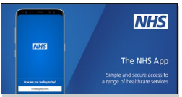You can also submit an eConsultation via the NHS app which is free to download from the App store on Apple devices or via the Google play store on Android devices.

NHS Patient App NHS England has introduced the first national app which is suitable for all patients over the age of 13 to use and are registered with a connected GP Surgery. With the NHS app you can: Check your symptoms using the ‘Symptom Checker’ and get immediate advice. Book or cancel appointments at your GP Surgery. Order repeat medication, view your medical record, register to be an organ donor and easily manage your preference on the NHS Organ Donor Register. Choose how the NHS uses your data. Complete and submit eConsultations. You can download the app from your smartphone via the App store or Google Play. Or for more information please ask reception.

**Park Surgery video updates**

We have decided to start putting video updates on our Facebook page periodically. Dr Matthews did the first one for us yesterday in which he chatted about the changes we have had to make during Covid. This received an immense amount of positive feedback and many of our patients seem to have loved it. Please let us know if there’s anything you would like to see from us.

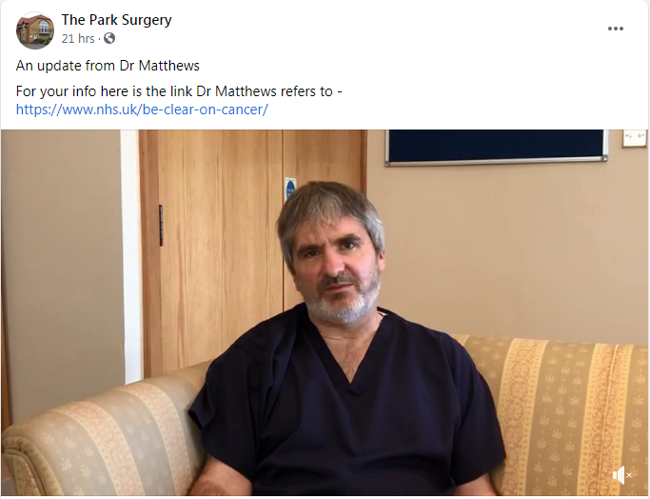

<https://www.facebook.com/watch/?v=797063061094152>

**Covid assessment unit at the Queen Vic**

Our Covid Assessment Unit at the Queen Victoria Hospital has worked extremely well; it has enabled us to assess patients with Covid symptoms in a safe way. We have not used the hot site anywhere near its maximum; we had only a few patients per day initially, if any. Until recently numbers have been so low that a decision was taken to reduce the number of appointments. The hot site is now open on Monday to Fridays afternoons only. It is staffed by both Park and Heron colleagues. We will be monitoring the number of patients visiting the hot site on a regular basis and the facility is still available for us to be open all day if numbers increase and we find we need more capacity.

**Flu clinics at the Queen Vic**

As we have such a large space at the Queen Victoria hospital we have been using it to hold our Flu Clinics this year. As you can imagine, with the Government guidelines and social distancing, we knew we would have to do something different this year to ensure all patients can social distance. What better way, than in one door, into a huge treatment room where several nurses can also socially distance, then out of another door as the exit, with parking outside. Patients have given us such amazing feedback for the Flu Clinics. We have plenty of staff members working on these days to ensure everything runs smoothly; it is still a lovely happy day as it has been in previous years. If anything it is more relaxed for the patients! You may have seen some of the lovely comments we received on Herne Bay Chatter, in case you didn’t, here are some of them –

* A very big thumbs up; it is so well organised, very impressed.
* Very well organised and very nice staff
* We went this morning. Very impressed, excellent staff and very well organised.
* Immensely impressed with the organisation and the friendliness of those staffing it.

Our October Flu Clinics are for patients with chronic illnesses and for the over 65’s. As you have probably seen on the news, all 50 – 64 year olds will also be invited to have the vaccine this year. We are still awaiting further information regarding this but do not expect to start vaccinating this age group until at least November and that is dependent on the vaccines being provided to us. We will send out further information about this to relevant patients as soon as we have it.

**What we’ve been up to**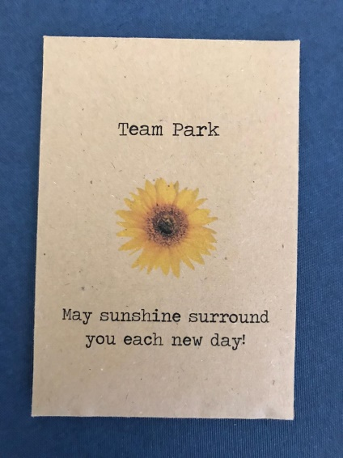

Sunflower competition

Our Social Team supplied each staff member with an envelope of sunflower seeds and set us up to grow the best sunflower. The competition had different categories, the brightest flower, the best bumble bee photo... In the photos here you can see that there’s definitely a photographer amongst our team!

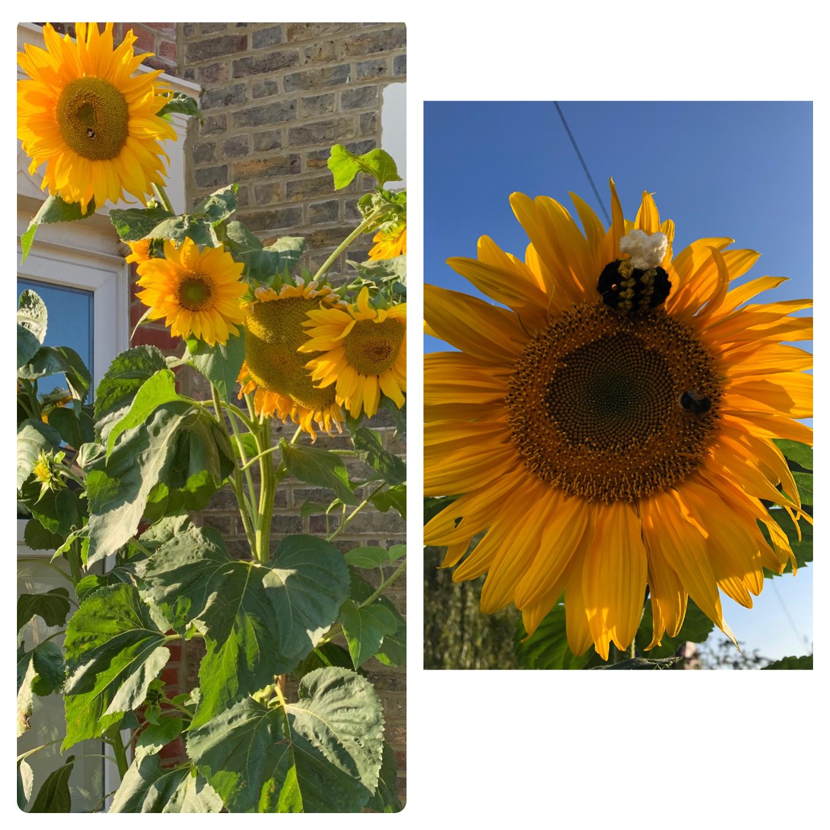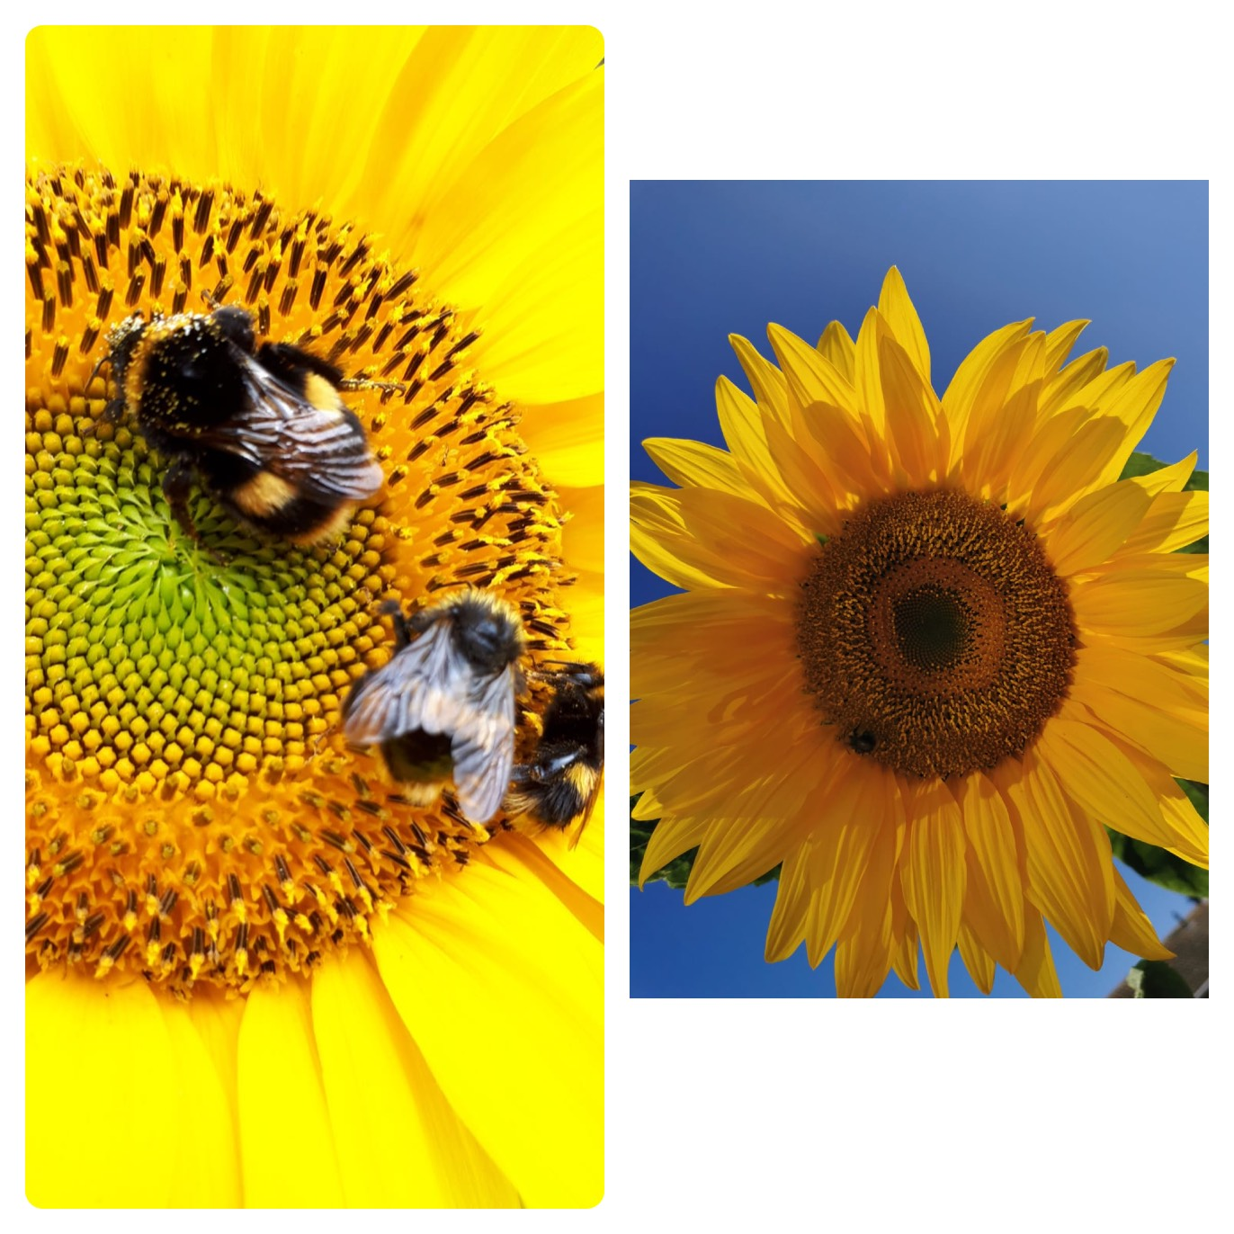

The sunflower competition bought some sunshine to our days. It was something everyone could be involved in, something fun for the staff’s children to enjoy too.

The Social Team have also provided us with different ‘pick me ups’ along the way to keep the moral high, whether it is cakes or fruit, they are very thoughtful indeed.

We have also been taking part in Pilates classes at Broomfield surgery, very good for mindfulness! In small groups to adhere to the Government guidelines, this has been very popular with the team too.

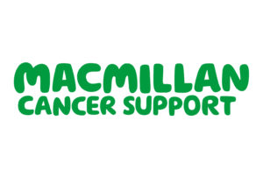Unfortunately we will not be able to host our wonderful Macmillan coffee morning this year. However, we still held a small socially distanced Macmillan coffee morning just for the staff and managed to raise £171 for this amazing charity.

**Patient feedback**

I thought it would be good to include some of the general feedback we receive. Here are some of the latest comments.

Nurse Jo was fabulous with my son and so friendly. He is autistic and although he’s high functioning, he does get very nervous. He was chatting away to Jo whilst she did his test and when we came out, he was still smiling. Thank you Jo

We have had lots of communication over the years with Jessica Willetts, and she never fails to help. She is amazing in any situation that comes our way, any obstacle, any question, any query or concern; she deals with or finds the right person to help us. She has called and emailed out of hours, she has even visited the home on one occasion when she should have been at home drinking wine or watch TV with her feet up.

I really don't know how I can express just how valuable we think she is and how much I want to say thank you. The words do not express enough how I can send my gratitude for her help and support.

Extremely pleasant and helpful receptionists

My husband and I are always treated well, Dr Eletu is amazing.

Receptionist was very nice and waiting area very clean with hand sanitiser